Comparative Molecular Docking Analysis of Catharanthus roseus Alkaloids Against Tubulin Protein (1SA0)

Ligands:
Catharanthine
Ajmalicine
Vindoline

Tools Used:
CB-Dock2
PyMOL

Prepared by:
Prepared by: AQSA KAMIL
Date:
14,May 2026

Introduction:
Cathatanthus roseus also know as the Sadhabhar ,of the family Apocynaceae .
It is cornerstone of modern oncology because it is the natural source of several potent chemotherapy.

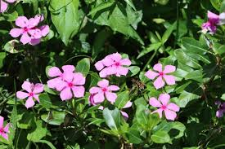

Vinblastine and vincristine are used to treat Hodgkin's lymphoma and leukaemia. Scientists later discovered that these compounds are biosynthesised by coupling plant alkaloids catharanthine and vindoline.

Alkaloids are nitrogen-rich compounds produced by plants, which help stop animals or insects from feeding on them. Nicotine is one such alkaloid, as is the caffeine from tea and coffee plants.

Armed with this knowledge, the research community were able to develop further semi-synthetic chemotherapeutic drugs from C. roseus. These are ‘semi’ because they are variations of compounds found in nature with modifications made by humans.

It is a complex biochemical factory that produces more than 130 terpenoid indole alkaloids (TIAs). These alkaloids are broadly categorized based on their chemical structures and the part of the plant where they are primarily found.

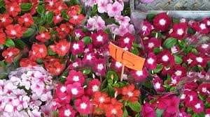

- Anti-Cancer Dimeric Alkaloids (The Vinca Alkaloids)
These are the most famous compounds in the plant. They are formed in the aerial parts (leaves and stems) through the natural fusion of monomeric precursors.
Vinblastine: High-value compound used for lymphomas and testicular cancer.
Vincristine: Vital childhood leukemia and lymphoma treatment drug.
Anhydrovinblastine: A key intermediate alkaloid that acts as a direct precursor to vinblastine.

- Monomeric Precursors (Leaf Alkaloids)
These alkaloids are synthesized in specialized cells within the leaves and serve as the building blocks for the anti-cancer dimers.
Vindoline: Found internally in specialized leaf cells; makes up one half of the vinblastine molecule.
Catharanthine: Exuded mostly onto the waxy surface of the leaves; forms the other half of the vinblastine molecule.

- Antihypertensive and Heart-Regulating Alkaloids (Root Alkaloids)
While the leaves specialize in anti-cancer compounds, the roots and basal stems synthesize a different set of alkaloids that primarily affect blood pressure and circulation.
Ajmalicine (Raubasine): An anti-arrythmic and antihypertensive agent used to improve blood flow to the brain.
Serpentine: Works alongside ajmalicine in the roots to help lower blood pressure.
Reserpine: A well-known antipsychotic and antihypertensive drug found in trace amounts.

- Other Notable Indole Alkaloids
Tabersonine: A precursor molecule involved in the complex multi-step synthesis of vindoline.
Vindolicine: A distinct leaf alkaloid possessing antioxidant capabilities.
Vincamine: Occasionally isolated in variations; helps expand blood vessels to improve memory and cognitive health.

How It Works

1.Targets Division: The compounds attack rapidly dividing cancer cells.
2.Blocks Scaffolding: They bind to tubulin proteins, stopping them from building microtubules (the cell's internal division skeleton).
3.Freezes Growth: Without this skeleton, the cancer cell cannot split its DNA and gets permanently trapped mid-division.
4.Triggers Death: The trapped cell recognizes the error and undergoes apoptosis (programmed self-destruction).

Types of cancer it works -
Acute lymphoblastic leukemia
Hodgkin’s lymphoma
Solid tumor
Can also treat advanced lung and metastatic breast cancer

Modern Lab Production Methods:

[plant cells/genetics]-->[bioreactor tanks]--->[semi-synthetic coupling]--->Purified medicine.

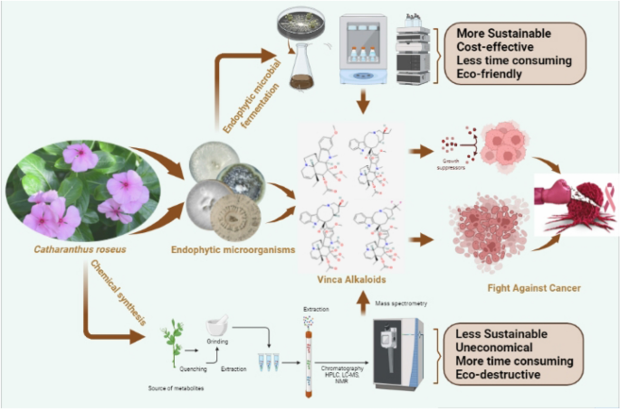

3️⃣ Methodology
Mention:
protein downloaded from: RCSB PDB
ligands downloaded from: PubChem
docking performed using: CB-Dock2
visualization using: PyMOL

4.Results Table

Ligand Best Binding Affinity (kcal/mol) Interpretation
Catharanthine -9.0 Strong interaction
Ajmalicine -8.3 Good interaction
Vindoline -8.0 Good interaction

- Docking Images
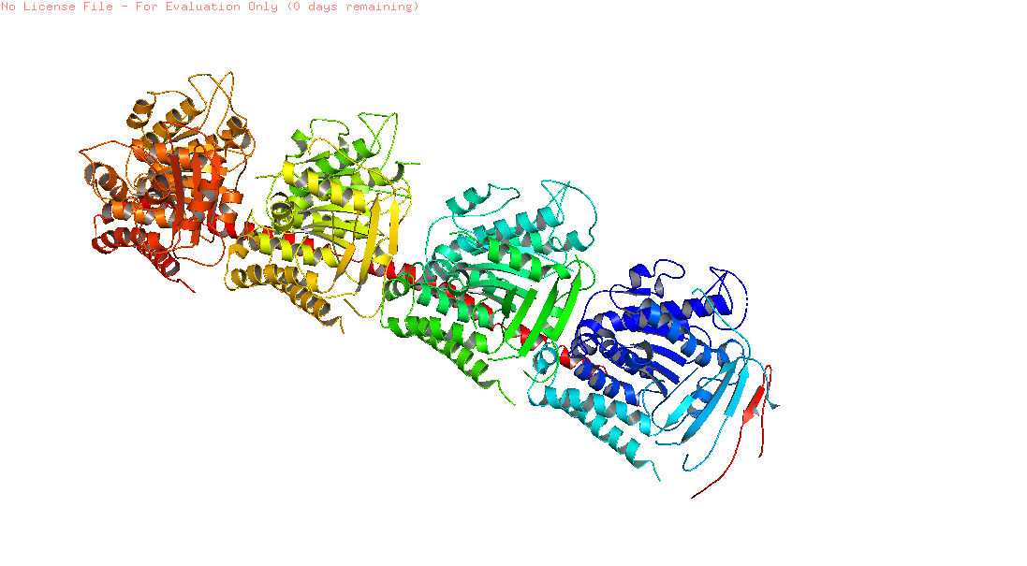
Fig: 1SAO_catharanthine

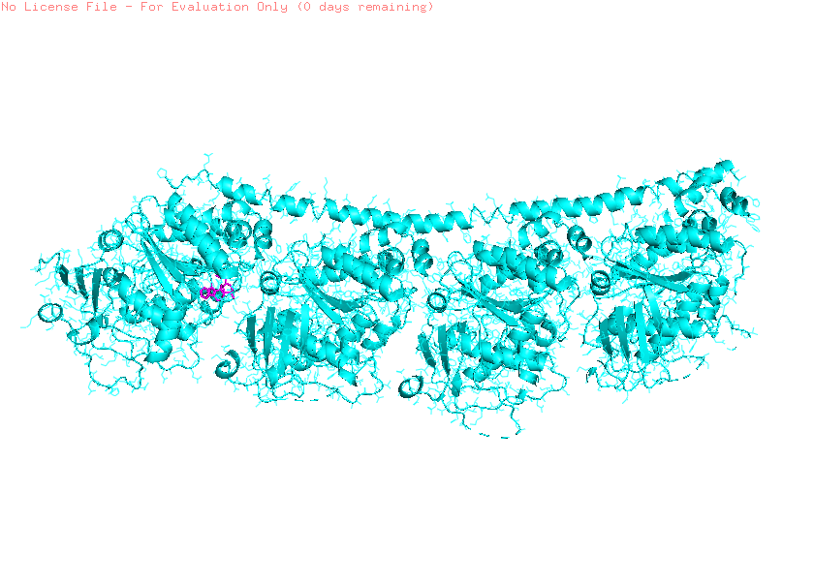
Fig: 1SAO_ajamalicine

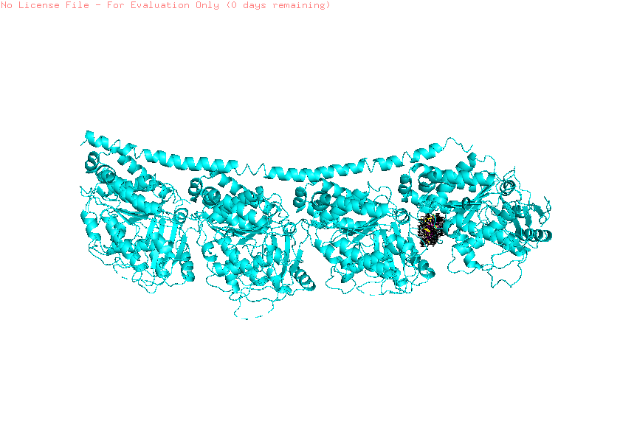
Fig:1SAO_vindoline

6️⃣ Discussion
Catharanthine showed strongest affinity of -9.0
all ligands interacted with tubulin
possible anticancer potential
alkaloids may stabilize binding differently

7️⃣ Conclusion
The study suggests that Catharanthus roseus alkaloids exhibit promising interaction with tubulin protein, with Catharanthine showing the strongest binding affinity among selected ligands.

